**Health Care Application**

**Short Form Product Guide**

Table of Contents

Filling out the Healthcare Application: Authenticated with Disability Rating 50% or Higher

Veteran Information Page 1: Name/SSN/D.O.B. 2

Veteran Information Page 2: Short-form Message and Place of Birth 3

Veteran Information Page 3: Mother’s Maiden Name 4

Veteran Information Page 4: Gender Identity 5

Veteran Information Page 5: Race/Ethnicity 6

Veteran Information Page 6: Mailing Address 7

Veteran Information Page 7: Home Address 8

Veteran Information Page 8: Email & Phone Number 9

Veteran Information Page 9: Medicaid 10

Veteran Information Page 10: Other Insurance 11

Veteran Information Page 11: Add Other Insurance Info 12

Veteran Information Page 12: ACA & VA Facility 13

Veteran Information Page 13: Confirmation & Submit 14

**10-10EZ Short-form for Veterans Authenticated with Disability Ratings of 50% or Higher**

### **Veteran Information Page 1: Name/SSN/DOB Confirmation**

* This is the shortened version of the 10-10EZ flow for an authenticated user with a disability rating of 50% or greater.
* The screen below is the first screen the user will see after clicking on the button to “Start the health care application”.
* We will pre pre-populate the Veteran info and ask them to continue if correct. 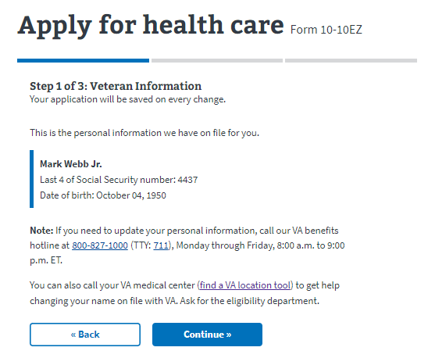

*Figure 1: Veteran* Name/SSN/DOB

### **Veteran Information Page 2: Short-form Message Display & Place of Birth**

* Next, we introduce new messaging to let the Veteran know that they are eligible to apply for health care using a shorter version of the 10-10EZ application.
* The user will have the opportunity to provide Place of Birth.

*Figure 2: Short Form Message*

### Veteran Information Page 3: Mother’s maiden name

* Enter or confirm Mother’s maiden name.

*Figure 3: Mother’s maiden Name*

### **Veteran Information Page 4: Gender Identity**

* Select gender or if pre-filled correctly click “Continue”.

*Figure 4: Gender Identity*

## Veteran Information Page 5: Race/Ethnicity

*Figure 5: Race/Ethnicity*

## 

## Veteran Information Page 6: Mailing Address

* Veteran has the option to select “yes” if mailing and home address are the same.

Same?

*Figure 6: Mailing Address*

## Veteran Information Page 7: Home Address

* If the Veteran answers “no” to whether their mailing and home address are the same, they will be shown a screen to enter their home address.

*Figure 7: Home Address*

## 

## Veteran Information Page 8: Email Address & Phone Number

*Figure 8: Email and Phone Number*

## Veteran Information Page 9: Medicaid

*Figure 9: Medicaid*

## Veteran Information Page 10: Other Insurance

*Figure 10: Other Insurance*

## Veteran Information Page 11: Add Other Insurance Info

* If they answer “Yes” to other insurance this page displays.

*Figure 11: Other Insurance*

## Veteran Information Page 12: ACA & VA Facility

*Figure 12: ACA & VA Facility*

## Veteran Information Page 13: Confirmation Page/Submit

*Figure 13: Confirmation Page/Submit*